Analysis Artifacts for Use Case 02 (Provider Payment)

**Table Of Contents**

1. Build ERD : Created by Mohanapriya Kottan Rajaraman 1

2. Robustness Diagram : Created By Vaishali Jain 2

3. Class Diagram : Created By Tejaswi Dasyam 3

4. Sequence Diagram : Created By Vaishali Jain 4

5. Communication Diagram : Created By Kopal Shinde 5

6. State Diagram : Created By Vaishali Jain 6

7. Data Flow Diagram : Created By Khushmeet 6

# Build ERD : Created by Mohanapriya Kottan Rajaraman

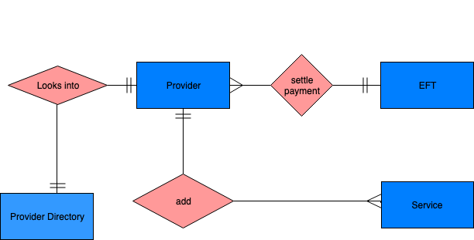

# 2. Robustness Diagram : Created By Vaishali Jain

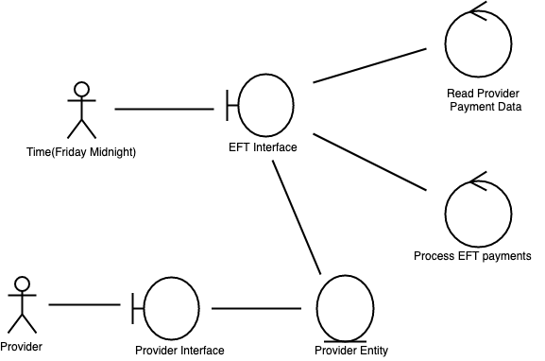

# 3. Class Diagram : Created By Tejaswi Dasyam

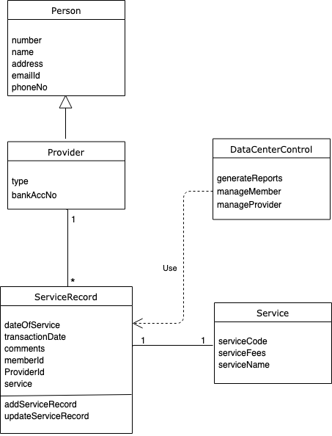

# 

# 

# 4. Sequence Diagram : Created By Vaishali Jain

# 

# 

# 

# 

# 

# 

# 5. Communication Diagram : Created By Kopal Shinde

# 

# 6. State Diagram : Created By Vaishali Jain

# 7. Data Flow Diagram : Created By Khushmeet Kaur

